**CHAPTER-3 SCREENSHOTS**

GUI – Main display window with name of the Employee Payment Management System

1.GUI of Employee Payment Management System

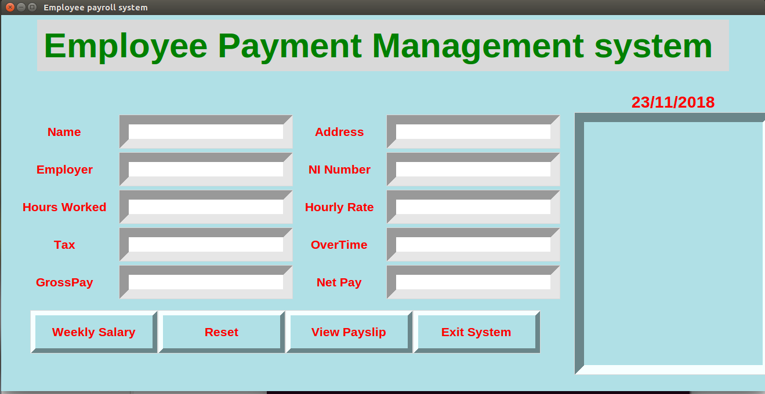

**it is a front end of the employee payment management system**

**2.calculate the employee weekly wages with payment slip:-**

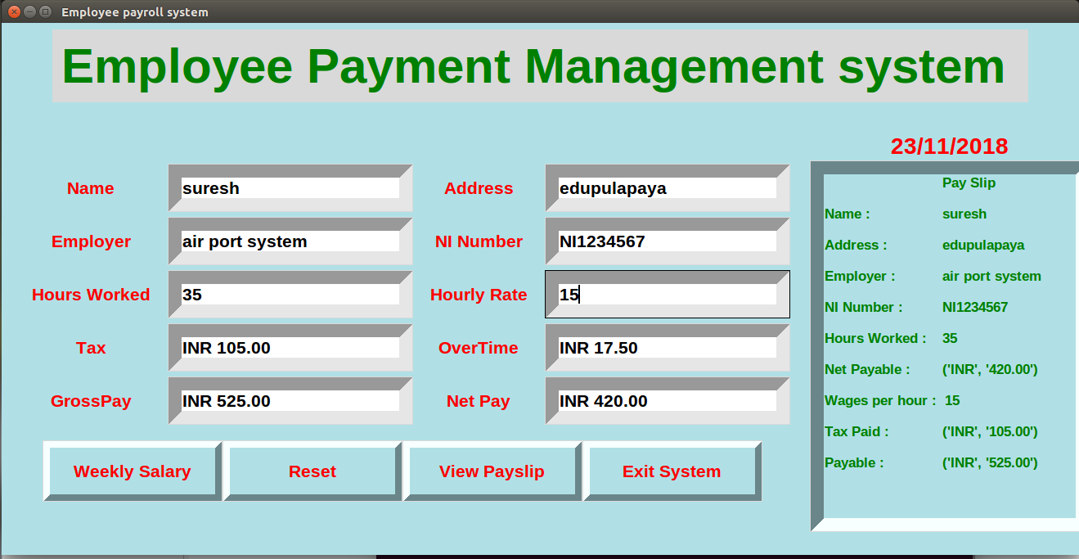

**after calculate the weekly wages with overtime work and generate the payment slip**

**3.Add Buttons**

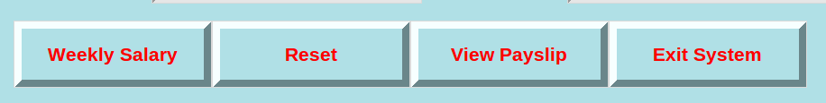

**1.weekly salary**

after clicking this button shows tax,gross salary and net salary and overtime bonus

**2.reset**

after clicking this button clear the all entries in this application

**3.view payslip**

after clicking this button it will shows the payment slip in the text box.  
**4.Exit system**

after clicking this button it will shows one window ask yes or no to destroy this application

**4.exit system**

